Work and Resources for Home Learning in the Event of School Closure
Class: Year 1/2 Mrs Main
Online Resources for Maths | BBC Bitesize: https://www.bbc.co.uk/bitesize/subjects/zjxhfg8  A website with a variety of games and videos.  Topmarks: https://www.topmarks.co.uk/Interactive.aspx?cat=8  A website with a variety of games and videos.  https://whiterosemaths.com/homelearning/  A website with activities to support your child’s understanding of Maths.  Maths Shed: https://www.mathshed.com/  Free for 14 days.
Online Resources for English (Speaking and Listening, Phonics, Reading and Writing) | Phonics Play: www.phonicsplay.co.uk  This website is a firm favourite in Year 1/2. They have a huge range of Phonics games at a range of levels. Please choose games in Phase 3, 4 or 5 for your child to reinforce what they have learned so far in Phonics this year.  Teach Your Monster to Read: https://www.teachyourmonstertoread.com/  A fantastic website that makes learning to read fun. The computer version is free to use.  Oxford Owl: https://www.oxfordowl.co.uk/for-home/  A great website with a huge range of books that your child can read online.  BBC Bitesize: https://www.bbc.co.uk/bitesize/subjects/zgkw2hv  A website with a variety of games and videos.  Topmarks: https://www.topmarks.co.uk/Interactive.aspx?cat=40  A website with a variety of games and videos.  Maths Shed: https://www.spellingshed.com/  Free for 14 days.
Websites for which school has a subscription for and your child has a login  If you have any problems logging in to any of these websites, please send a Class Dojo message to Mrs Main and she will send you a reminder of your log in details. | Lexia: https://www.lexiacore5.com  Reading – this is a firm favourite that the children really enjoy using in school. The website automatically allocates work that matches your child’s reading level. I cannot recommend this website highly enough.  Bug Club: https://www.activelearnprimary.co.uk/login?c=0  Reading – lots of books that you can read online.  PurpleMash: www. https://www.purplemash.com/  Mathletics: https://login.mathletics.com/
More Online Resources | https://www.bbc.co.uk/teach/supermovers/ks1-collection/zbr4scw  https://imoves.com/imovement-signup  These are websites that will help your child to take part in active activities indoors, with curriculum linked videos. You need to join Imoves, but this is free to do.  Please try to keep active each day.  Year 1 Twinkl free resource pack: https://www.twinkl.co.uk/resource/year-1-school-closure-home-learning-resource-pack-t-e-2549910  Year 2 Twinkl Free Resource Pack: https://www.twinkl.co.uk/resource/year-2-school-closure-home-learning-resource-pack-t-e-2549911  Download the brilliant pack of resources that matches the year group that your child is in to keep them busy and learning. With a range of fun, engaging and challenging activities, children will practise fundamental skills and reinforce concepts that have already been taught to them during Year 1 or Year 2.
Current Topic Key Questions | Current Topic: Castles, Knights, Princesses and Dragons  History: Who is Queen Elizabeth II? Find out about her coronation. Can you create a crown, a sceptre and an orb (just like the ones that queen had at her coronation)? Take photo and upload it to Class Dojo.  Geography: What is the name of the building that Queen Elizabeth II lives in most of the time? What city is this building in? What makes this city important? What country is the city that Queen Elizabeth II lives in called? Create a model of Buckingham Palace and upload a photo to Class Dojo.  Art: Who was Paul Klee? Please find out about the artist Paul Klee and his painting, Castle in the Sun. Can you create a piece of artwork (of a castle) in a similar style?
Reading | Please ensure your child reads for at least 15 mins every day. Allow them to use Lexia to do this if you do not have suitable books at home.
Spelling | Please check your child’s learning of the attached spellings.
Phonics | It is very important that your child continues to complete Phonics activities on a daily basis - use www.PhonicsPlay.co.uk (choosing Phase 3 to Phase 5 games), www.teachyourmonstertoread.com and www.Lexiacore5.com

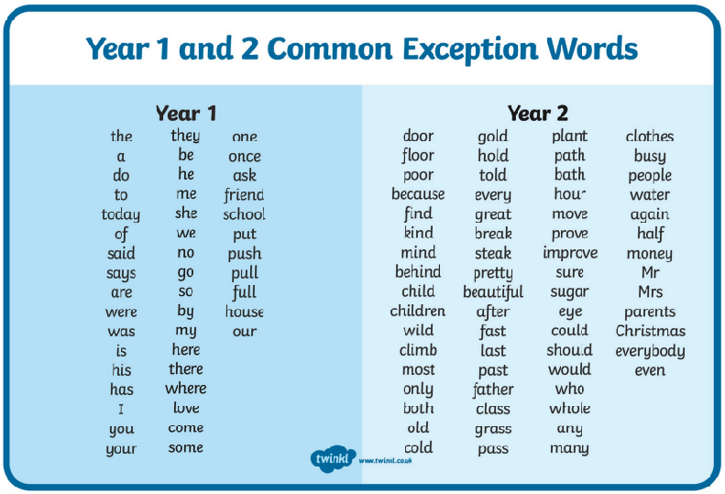
Simonside Primary School

