Year 6 Weekly Homework
Topic: Were the Victorians really vile?
Your homework is your choice! There are 9 challenges to choose from below. Please try and complete 6 challenges this week.
Challenge 1  Rounding to 1,000,000  Write down two 7-digit numbers. Add the numbers together and round the answer to the nearest 1,000,000.  Now round the original numbers and add them together. Do you get the same answer?  Try it again with different numbers. What do you find?  EXAMPLE  6,789,423 + 5,865,543 = 12,654,966  Rounded to the nearest 1,000,000 = 13,000,000  7,000,000 + 6,000,000 = 13,000,000  Yes I got the same answer. | Challenge 2  Science-Evolution  Research Charles Darwin and create a fact file about him. Include information about his Theory of Evolution.  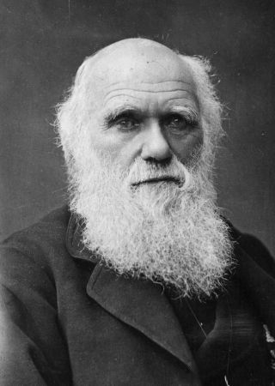 | Challenge 3  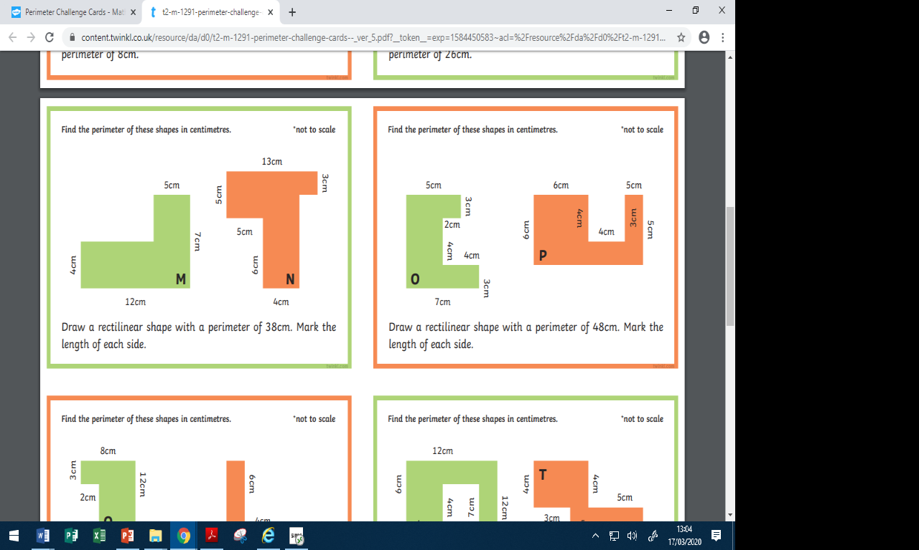  Perimeter
Challenge 4  Spellings  Practise the Year 5/ 6 spelling words from your list. Choose 5 words and then write a synonym, antonym, the meaning and an example of how to use the word in a sentence. | Challenge 5  Biography    Write a biography of the author of your current reading book. | Challenge 6  Times tables  Play on Hit the Button (Topmarks) - focus on times  tables, division facts and squared  numbers.  https://www.topmarks.co.uk/maths-games/hit-the-button
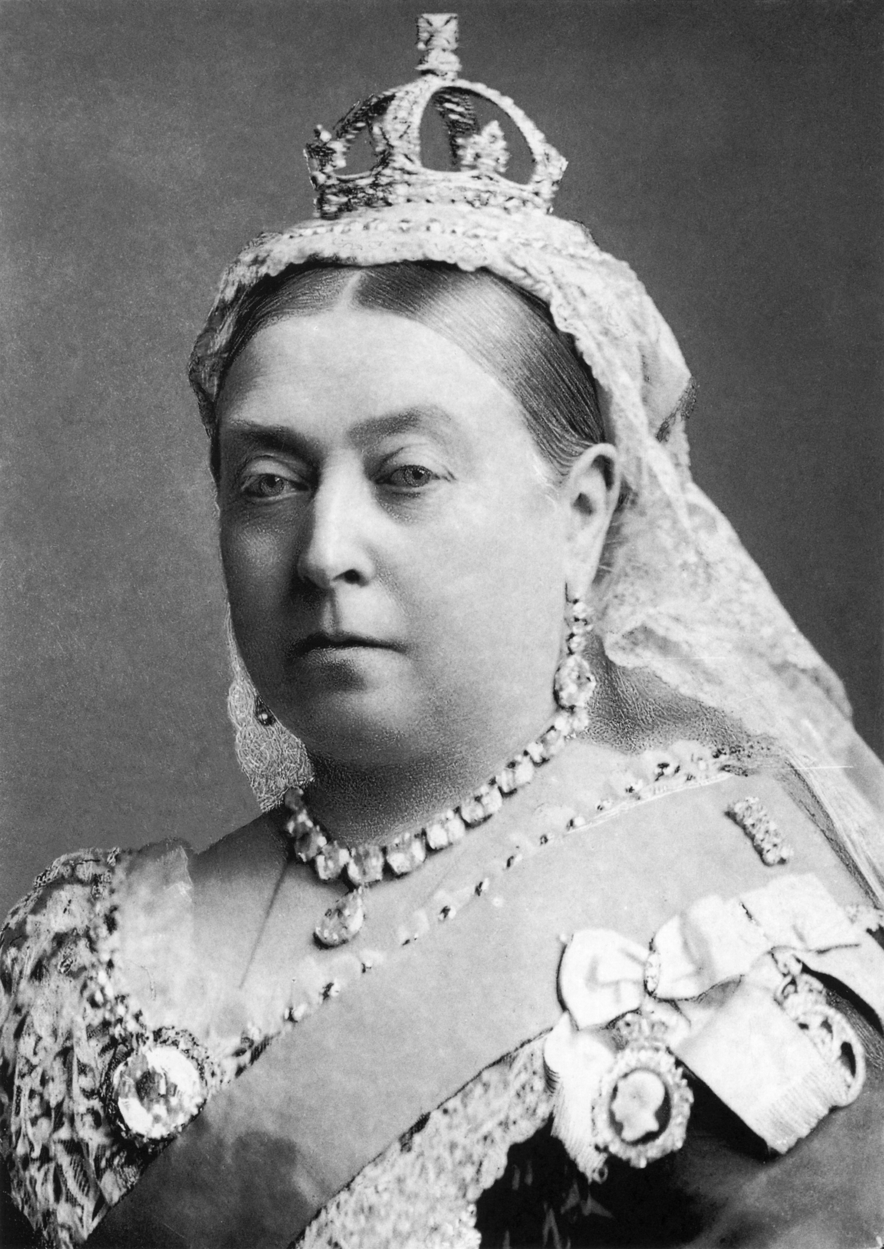  Challenge 7  Persuasive argument  Would you rather live in the Victorian era or present day? Write a persuasive argument giving your views. | Challenge 8  Area  Design a poster to show the formulas for finding the area of a square, rectangle, parallelogram and triangle. | Challenge 9  SPaG-Adverbs  Write an adverb for each letter of the alphabet.  E.g.  A-Anxiously  B-Bravely

