Work and Resources for Home Learning in the Event of School Closure

Class: Year 2 Teacher: Mr Singh
Online Resources | BBC Bitesize: https://www.bbc.co.uk/bitesize/levels/z3g4d2p  Topmarks (Maths and English): https://www.topmarks.co.uk/  Twinkl free resources packs: https://www.twinkl.co.uk/resource/year-2-school-closure-home-learning-resource-pack-t-e-2549911  BBC Supermovers- https://www.bbc.co.uk/teach/supermovers/ks1-collection/zbr4scw
Websites for which school has a subscription for and your child has a login  *Logins were sent home in the front of homework books at the start of the year. If you can’t locate this then please contact me via Class Dojo. | Mathletics: https://login.mathletics.com/  TT Rockstars: https://ttrockstars.com/  Bug Club: https://www.activelearnprimary.co.uk/login?c=0  Lexia - https://www.lexiacore5.com/  Purple Mash - https://www.purplemash.com/sch/simonside
Current Topic | Current Topic: Castles, Dragons, Princesses and Knights.  Please refer to current homework grid for this. The homework states a minimum of 5 homework tasks must be complete but due to the closure it would be beneficial to do more where possible.
Reading | Please ensure your child reads for at least 10 minutes every day.
Spelling | Please check your child’s learning of the attached spellings (also found in back of homework books).
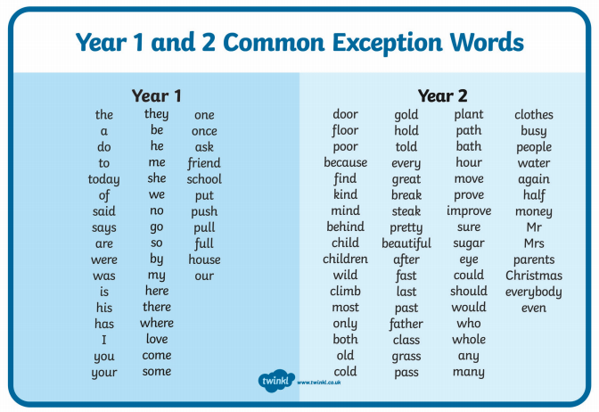
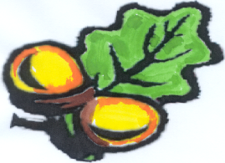
Simonside
Primary School

