**PSHE and RE**

Children will learn the following skills:

-Following rules

-Understanding how behaviour affects others

-Listening to others

-Responding when asked

-Recognising and making the right choices

-Understanding the reward scheme (dojo)

-Responding to positive/negative behaviour

-Sharing opinions

- What makes you happy?

- What makes you healthy?

**- Belonging to groups**

Links to Literacy: Speaking and Listening

Links to Maths: Counting (reward scheme smileys/stars)

**Art & Design**

* Use a range of materials creatively
* Paint mixing
* Recognising shades of colour
* Learn about the work of Andy Goldsworthy and copy the work of this artist

Links to Literacy: Listening and following instructions and use of new vocabulary.

Links to Maths: Measuring materials, mixing prime colours and linking it to number bonds.

**Science**

Children will be learning to identify the body parts of the human anatomy and will be learning to work scientifically.

* Identify, name, draw and label the basic body parts of the human body
* Say which body part is associated with each sense
* Animals Including Humans:
* Identify and name a variety of common animals
* Identify Carnivores, Omnivores and Herbivores
* Describe and compare the structure of common animals (i.e fish, pets, mammals)

Links to Literacy: Speaking and listening skills and recording observations, learning new vocabulary (Letter formation, Handwriting)  
Links to Maths: Using measurements to record information

**PE**

Fundamentals: - Intervention to improve weaknesses and

improve strengths. (Involves throwing, catching, balancing, slow/fast movement and more)

-Moving around the space safely

Links to Literacy: Listening and following instruction, speaking + communication

Links to Maths: Measuring, Distance, and Timing events

**Computing**

* Learning the basics (logging on, typing, using a mouse,

using iPad apps)

* Use technology safely and respectfully, keeping personal

information private, identify where to go for help and

support when they have concerns about content or contact on the internet or other online technologies.

* Using the purple mash programme.

**Geography / History**

Children will be learning about their local area and school grounds as well as the story of Grace Darling

* Geographical skills and fieldwork
* Name and locate places of local interest
* Drawing our own maps of the school and the surrounding areas
* Locate our school and local area on a bird’s eye view map
* Walk around the inside of our school and rooms we have not been in yet
* Walk around the outside of our school grounds
* Learn and understand local events that have occurred

in the children’s local area

* Understand ‘Time’ as a concept of things that happened in the past, present and future

Links to Literacy: Speaking and Listening, Writing, Reading, Letter formation, Handwriting and learning historical/geographical language/vocabulary.

Links to Maths: Understanding Time, counting and sequencing events

Superheroes

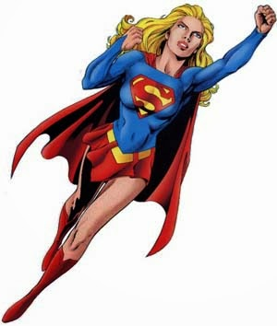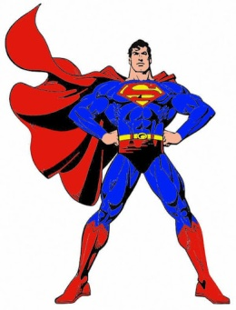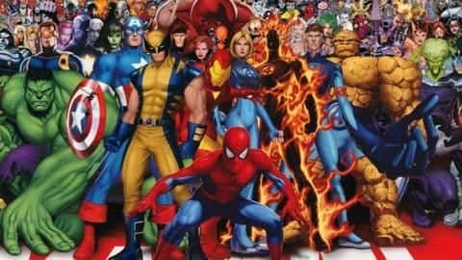

**Music / Dance**

The children will be learning the following skills this term:

-See charanga scheme

-Using their voices expressively by singing songs and performing rhymes  
- Dancing daily

Links to Literacy: Listening and following instruction, learning musical vocabulary, speaking expressively and Reading

Links to Maths: Singing Songs about counting.

**British Values**

The Rule of Law

Democracy

Individual Liberty

Mutual Respect

**Wow experiences**

* Local area autumn walk
* Walk around our school grounds
* Getting to know a new classroom and new teachers