Work and Resources for Home Learning in the Event of School Closure

Class: Year 5 Mrs Mason
Online Resources | BBC Bitesize: https://www.bbc.co.uk/bitesize/subjects/z826n39  Topmarks (Maths and English): https://www.topmarks.co.uk/  Twinkl free resources packs: https://www.twinkl.co.uk/resource/year-5-school-closure-home-learning-resource-pack-t-e-2549914
Websites for which school has a subscription for and your child has a login | Mathletics: https://login.mathletics.com/  TT Rockstars: https://ttrockstars.com/  Bug Club: https://www.activelearnprimary.co.uk/login?c=0  Purple Mash: https://www.purplemash.com/sch/simonside
Current Topic Key Questions | Current Topic: The Vikings  Research the following:  What was the name of the Viking explorer who discovered America?  What are the Vikings most remembered for?  https://www.bbc.co.uk/bitesize/topics/ztyr9j6
Reading | Please ensure your child reads for at least 30 mins every day.
Spelling | Please check your child’s learning of the attached spellings.
Weekly learning grids | Each week there will be a learning grid of activities that your child can access.
Computing | In Computing it is really beneficial for children to have fast typing skills. Please encourage your child to spend time on the following website:  http://www.bbc.co.uk/guides/z3c6tfr#z34thyc  If you ‘Google’ ‘Dance Mat Typing’ you will also find the link easily.

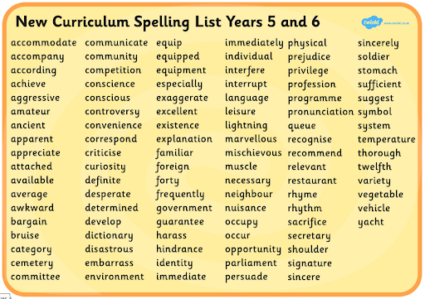
Questions to ask about Reading
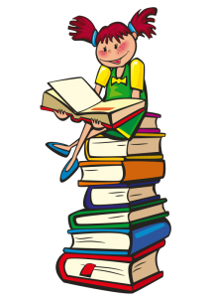

What words tell you how the character is feeling?

How might you solve the problem of the character in your story?
Would you have done something different?

Can you explain what happened in each chapter using only one or two sentences?

Is this book one of your favourites?
Is this one of your favourite authors?
Can you explain your answers?

What do you think will happen next? Can you explain why you think that? (Encourage them to use clues in the text)

Can you talk about what you did and did not like about the story and explain why you feel that way?

