Nursery School closure activity ideas to try at home – Summer 2 week 13.7.20
Topic – The Seaside/Under the Sea
Personal, Social and Emotional Development  CBeebies has some wonderful poems to support a range of topics to support your little ones.  - Kindness  - Morning routines  - Brushing teeth  - Tidying up  - Friendships  https://www.bbc.co.uk/sounds/play/live:cbeebies_radio  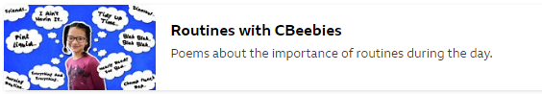  https://www.bbc.co.uk/cbeebies/radio  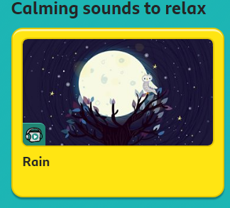 | Communication, Language and Literacy  Story of the week  Read or watch on youtube  The Lighthouse Keeper’s Lunch  by Ronda and David Armitage  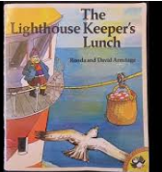  https://www.youtube.com/watch?v=46wCRq50Wwg  Key questions:  Where did Mr and Mrs Grinling live?  Why did Mr. Grinling have to clean and polish the light?  How did Mr. Grinling get to the lighthouse?  How did Mrs. Grinling manage to get Mr. Grinling’s lunch to him?  What was in the picnic basket in the story?  What happened to Mr Grinling’s lunch?  How did Mrs. Grinling stop the seagulls from eating Mr. Grinling’s lunch?  What would you like in your picnic basket?  What is your favourite food?  Is your picnic lunch healthy? How could we make it even healthier?  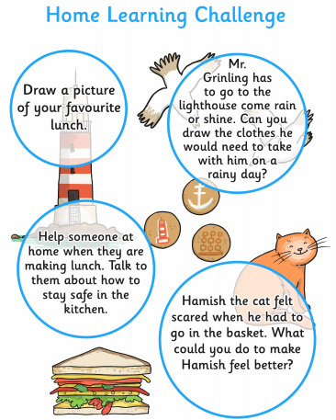  Other Book Recommendations  Billy’s bucket  Lucy and Tom at the seaside  Sall and the limpet  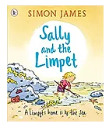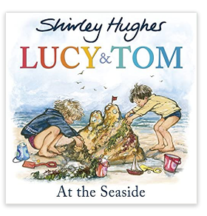  Let’s get talking! – Story stones are great for developing children’s speaking and listening skills.  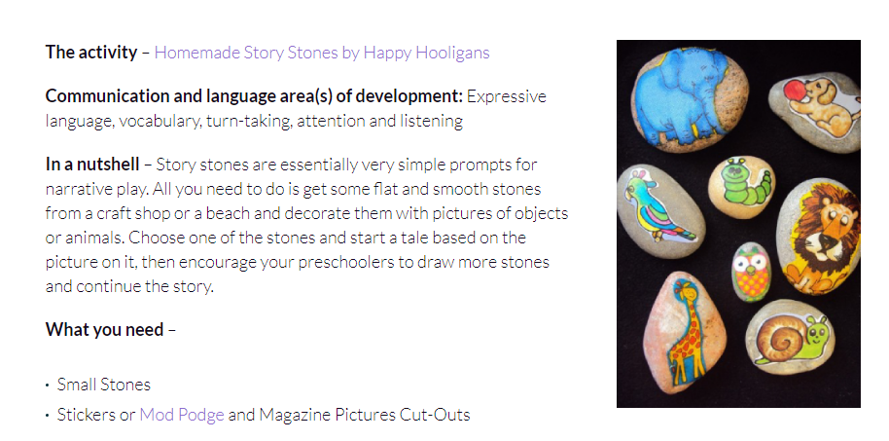  Phonics on Cbeebies – This website introduces the children to the initial letter sounds . The link below demonstrates how each letter sound is pronounced.  Continue to focus on s-a-t-p-i-n  then move on to:  m-d-g-o-c-k  https://www.bbc.co.uk/cbeebies/watch/cbeebies-phonics-playlist?collection=playlist-collection#playlist  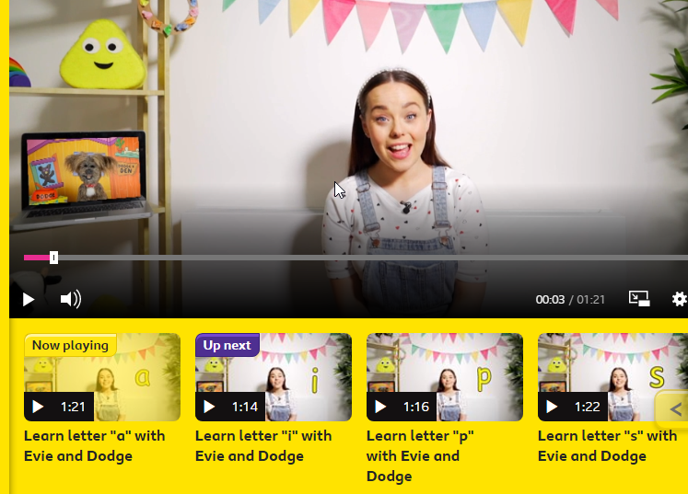  Orally blending sounds  Using the letters we’ve already learned, now see if you can have a go at blending using s,a,t,p,i,n. watch the link below and see if you can join in.  https://youtu.be/MQpw77l-l6M | Physical Development  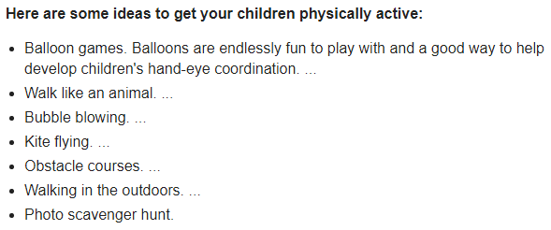  Cosmic kids yoga adventure – Tommy the bedtime turtle  https://www.youtube.com/watch?v=gCLW77sABTc  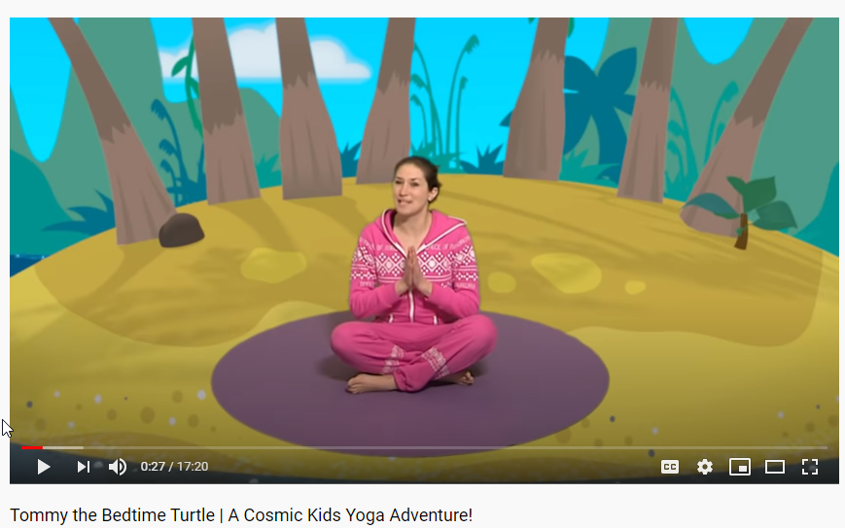  Fine motor activities  https://www.twinkl.co.uk/resource/at-the-seaside-pattern-tracing-activity-t-tp-2549293  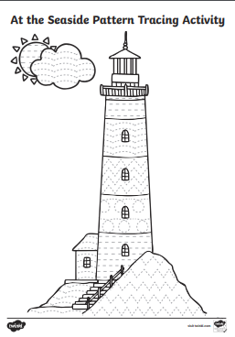  https://www.twinkl.co.uk/resource/t-l-51980-fine-motor-skills-activity-cards  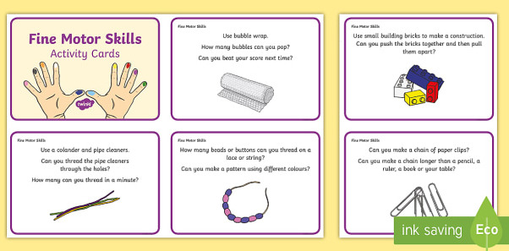  For the children starting Reception please continue to practise recognising and writing their first name.  Please stick to lower case letters apart from their initials. Letter formation sheets are available to download on Twinkl.  www.twinkl.co.uk  Take a look at the formation for the letters in your child’s name and make a simple name card. Start with tracing over or using a yellow pen for the children to over write  Encourage your child to start at the red dot and follow the formation correctly.  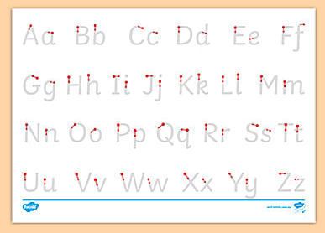
Maths  Continue to count, count and count so more!  Match numbers to quantities.  Play board games  Continue to sing a range of numbers rhymes use fingers to support language of one less.    Ask ...how many now? Count?  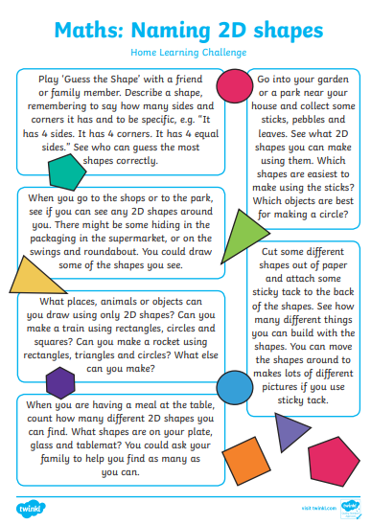  Our story of the week includes the days of the week.  Reinforce language of time by using other key vocabulary related to time  Yesterday, today and tomorrow.  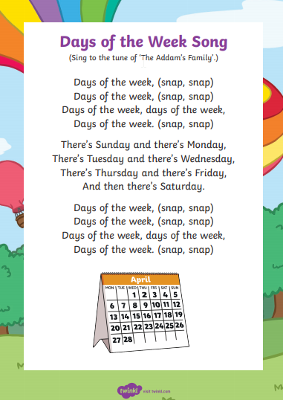 | Creative  Can you make a telescope like Mr.Grinling’s?  What happens when you look through a telescope or binoculars?  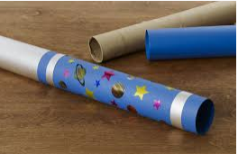  Can you make your own lighthouse?  What materials will be best?  Why does the lighthouse need to be tall?  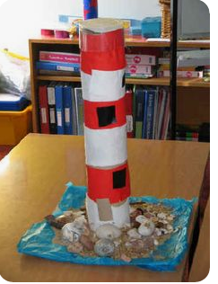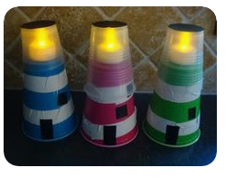  Can the children re-enact the story using visual prompts or have a try at creating their own story setting.  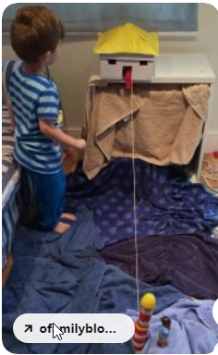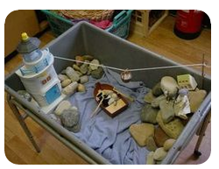  Have a try at making saltdough.  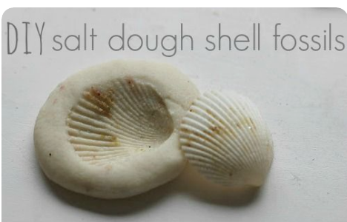 | Knowledge and Understanding of the World  Key vocabulary linked to the story  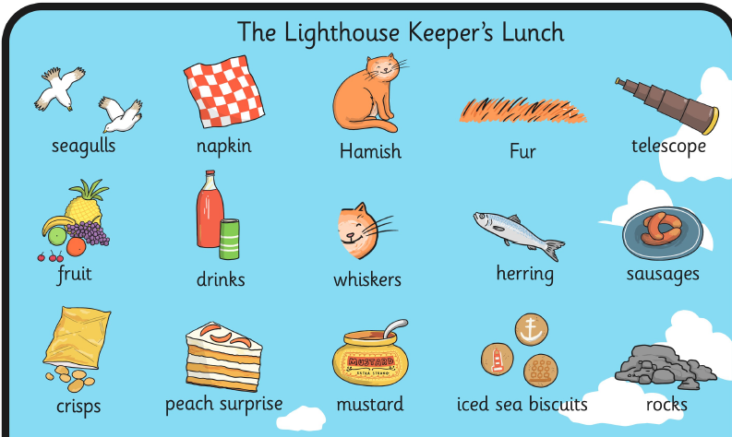  Read and talk about the slides below.  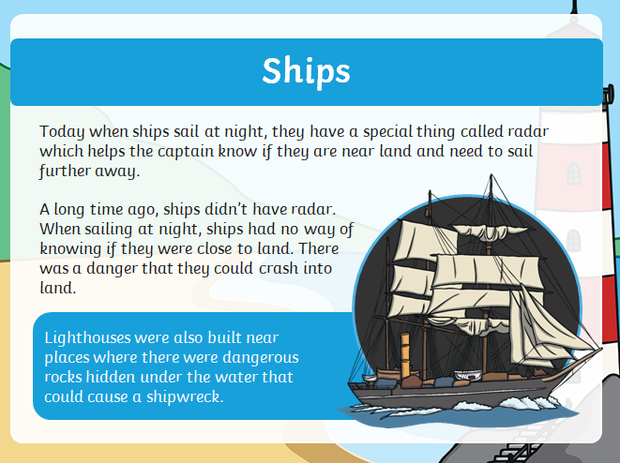  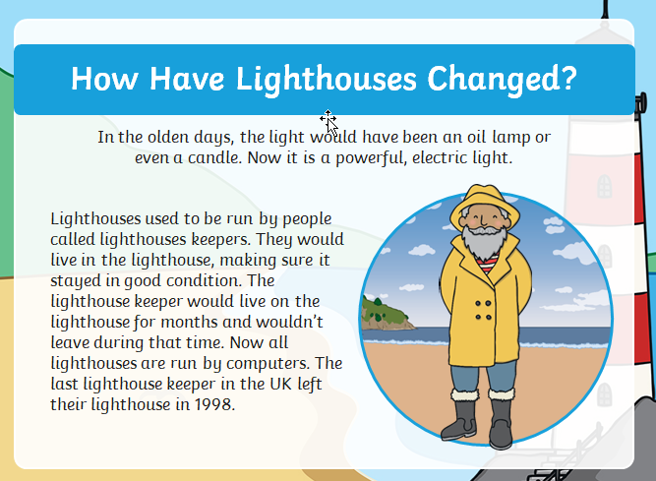  Challenge!  Try and make a model boat that can float.  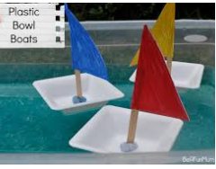  Talk about which materials would be best and why?  How can pieces be joined together?  How can test to see if the boat will float?  Create your own picnic lunch – talk about foods which are healthy/unhealthy.  Explain that it is ok to have treats in moderation.  https://www.twinkl.co.uk/resource/t-t-21500-a-picnic-lunch-eyfs-adult-input-plan-and-resource-pack  

