**GOOD TIMEKEEPING MATTERS**



**Simonside**

**Primary School**

**Did you know that being 15 minutes late each**

**day is the same as missing two weeks of**

**school? (Over one academic year)**

[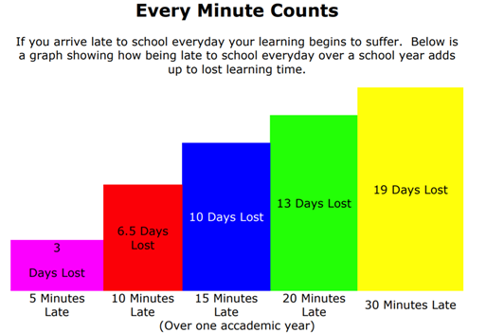](https://www.google.co.uk/url?sa=i&rct=j&q=&esrc=s&source=images&cd=&ved=2ahUKEwiO6-X1heXmAhUOxYUKHdifAmcQjRx6BAgBEAQ&url=https%3A%2F%2Fparkside.herts.sch.uk%2Fattendance-and-lateness-letter%2F&psig=AOvVaw1iql3ZRj8cejtFSArZC-Sr&ust=1578058410487011)

**EVERY DAY COUNTS**

**Every minute is important**

**Lost minutes = Lost learning**