Simonside Primary School
Attendance and Punctuality 2019-2020
At Simonside we recognise that good attendance and punctuality is vital for success. Children at Simonside are expected to have at least 97% attendance.

Staff and Governors at Simonside encourage parents/carers to work together to promote good attendance and punctuality across the school.

Research shows that good attendance and punctuality can:
Improve attainment
Develop positive friendships and social skills
Build confidence
Develop life skills
Lay the foundations for a child’s future
Although parents/carers have the legal responsibility for ensuring their child’s good attendance, the Head teacher and Governors at our school work together with other professionals and agencies to ensure that all pupils are encouraged and supported to develop good attendance habits.
Children who are persistently late or absent soon fall behind with their learning. Children who are absent from school frequently develop large gaps in their learning which will impact on their progress and their ability to meet age related learning expectations. A child whose attendance drops to 90% each year will, over their time at primary school, have missed two whole terms of learning.
Authorised and Unauthorised Absences

The school has, by law, to classify every absence mark a child has as either ‘authorised’ or ‘unauthorised’. Schools have a duty to monitor every child’s attendance and take swift action when attendance falls below the expected standard. An absence is classified as authorised when a child has been away from school for a legitimate reason and the school has received notification from a parent or carer. Only the school can make an absence authorised.

Authorised Absences
- Illness
- Medical/Dental (where a hospital letter or appointment card has been seen)
- Bereavement
- Agreed special occasion or exceptional circumstances
- Religious observance
- Approved sporting activity

Unauthorised Absences
This type of absence is not permitted by law. School cannot authorise absences for:
- Going to the shops or hairdressers
- Going on holidays
- Visiting relatives
- Children not wanting to come to school
- Staying off because a sibling is off poorly
- Birthdays
- Waiting for a delivery
- Oversleeping because of a late night
- Getting up late and not wanting to come into school for that day
- Keeping your child off because you are ill
- Appointments for other family members

Holidays should not be taken during term time.
From September 2019, the Governing Body will be notifying the Local Authority Attendance Service about any pupil taking holidays in term time. This may result in the issuing of a Fixed Penalty Notice.
A Penalty Notice is a fine of £60 if paid within the first 21 days which
increases to £120 if paid between 22 and 28 days. Thereafter, if the Penalty remains unpaid this may lead to prosecution through the Magistrates Court.

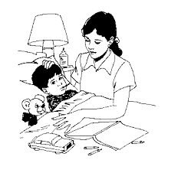
Illness
We know that young children can be susceptible to illness and understand that if they are poorly they may need time off to recover. This is reflected in our school target for every child to have at least 97% attendance.
When children have an illness that means they will be away from school long term, the school will do all it can to send material home, so that they can keep up with their school work.
Where over the course of an academic year, a child has repeated periods of illness, the school will write to parents to ask them to provide medical evidence for each future period of illness related absence. This evidence should be a doctor’s note, appointment card/letter or copy of a prescription. We may seek written permission from parents for the school to make their own enquiries. Alternatively, we may make a referral to the School Health Advisor to offer support.
What to do if your child is going to be absent
- Telephone school on the first day of absence. If contact has not been made, the information will be passed onto our Parent Support Officer or Attendance Officer who may come and visit children’s homes to investigate why they are not in.
- Keep school informed if more than one day’s absence is necessary.
- Avoid medical appointments in school time but, if absolutely necessary, bring your child to school before and/or after the appointment.
- Speak to the class teacher who will be able to provide you with work for your child if appropriate.

If you would like your child to have time off school for any reason- including holidays and medical appointments- you are required to:
- Collect a form (Application for Leave of Absence) from the school office BEFORE the absence.
- Complete the form with as much information as they can about why you want to take your child out of school and return it to school.
- Medical/Dental Appointments should be supported by evidence i.e. appointment card/hospital letter.
Punctuality
Punctuality is crucial. Lateness into school causes disruption to your child’s learning and to that of the other pupils in the class. It is vital that all pupils arrive at school on time at 8.55am (doors open from 8:50am). Learning starts as soon as the child walks into their classroom. Being late is extremely detrimental to their learning.
Registration takes place as soon as the children come into class. Any child arriving after 9:00am will receive a late mark and the number of minutes late is recorded. Any children who are late must report to the main reception and report to Miss Monaghan to receive their mark and give the reason why they are late. Any child arriving after 9:30am will have their late arrival classed as an unauthorised absence.
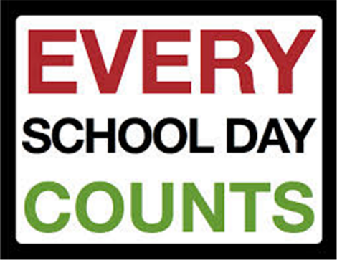
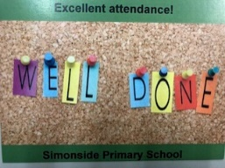

Simonside Star Attenders

Attendance Ambassadors are a group of children helping to improve attendance and punctuality at Simonside.

- Classes are given a letter for every day they have 100% attendance. When they have the 13 letters to spell out ‘Star Attenders’ that class will have pizza as a treat.

- The class with the best weekly attendance will receive an extra playtime, a trophy and ‘Simon’ our attendance mascot.

- If your child has 97% or above attendance for one half term, they will receive a certificate.

- If your child has 100% attendance for one half term, they will receive a special post card.

