Work and Resources for Home Learning in the Event of School Closure

Class: Year 4 Miss Wilson
Online Resources | BBC Bitesize: https://www.bbc.co.uk/bitesize/subjects/z826n39  Topmarks (Maths and English): https://www.topmarks.co.uk/  Twinkl free resources packs: https://www.twinkl.co.uk/resource/year-6-school-closure-home-learning-resource-pack-t-e-2549915
Websites for which school has a subscription for and your child has a login | Mathletics: https://login.mathletics.com/  TT Rockstars: https://ttrockstars.com/  Bug Club: https://www.activelearnprimary.co.uk/login?c=0
Current Topic Key Questions | Current Topic: Comparison of France and England  Research the following:  What are some of the key landmarks in France?  How are different regions within France different?  What are the key similarities and differences between France and England (think about tourism, climate, culture and physical geography)
Reading | Please ensure your child reads for at least 30 mins every day.
Spelling | Please check your child’s learning of the attached spellings.
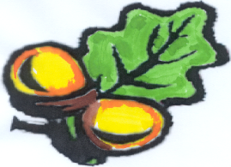
Simonside
Primary School

