Nursery School closure activity ideas to try at home – Summer Term 22.6.20
Topic – The Seaside/Under the Sea
Personal, Social and Emotional Development  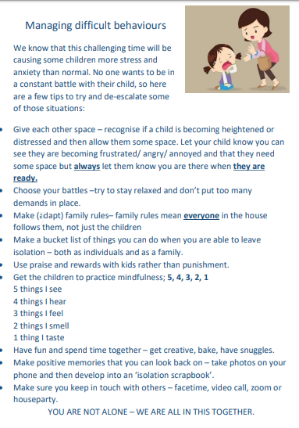  Have a go at building a kindness tree. This lovely activity could be done as a family. Either using paper/ card or an actual tree/ bush you may have in your garden. The idea is, each time your child demonstrates kindeness towards someone else, a leaf/ heart/ flower is added to the tree. How quickly will it take your tree to be in bloom?  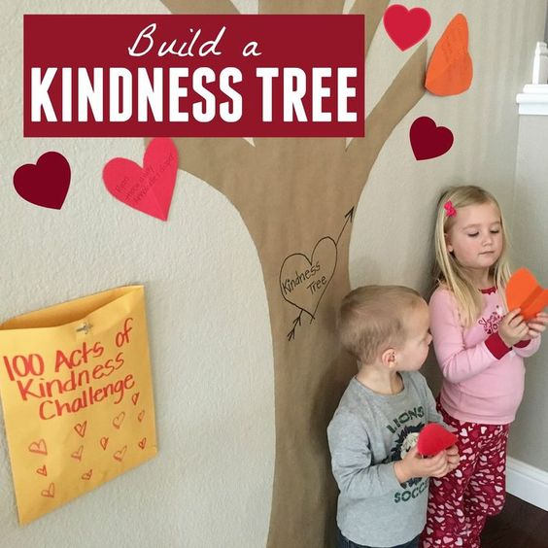 | Communication, Language and Literacy  Let’s get reading together.  You still have a week left to complete the reading challenge. 30 books in 30 days!  For the next 30 days (All of June) We’d like you and your child to read or listen to at least one story every day. Keep a record of the stories read and your child will be awarded with a either a gold, silver or bronze certificate.  Let’s get talking!  Plan a day at the seaside with your child. What will you need to take? Recap on Kippers visit to the beach last week. What did he pack? Use the suitcase template to jot your child’s ideas. They can draw pictures.  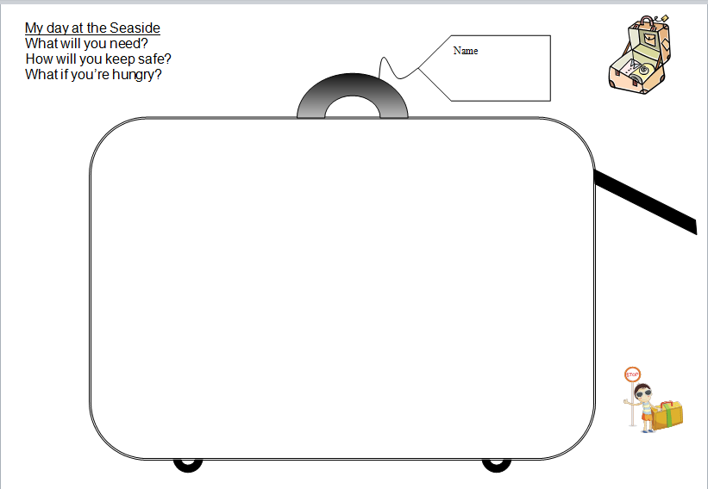  Phonics – Phase 1 – Phonics Play  https://new.phonicsplay.co.uk/resources/phase/1  Username: march20  Password: home  Click on parents icon to find lots of useful info to help your child at home.  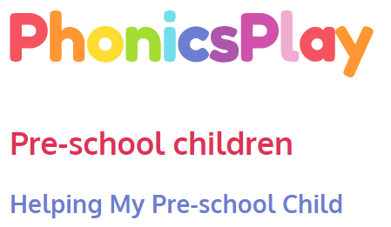  https://www.phonicsplay.co.uk/parents/pre-school-children  Select Phase 1 interactive resources to practise listening phonic skills.  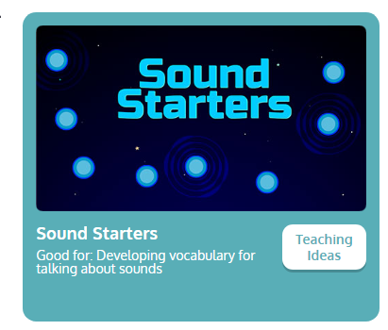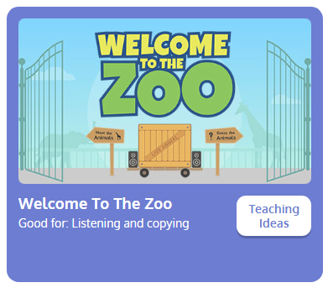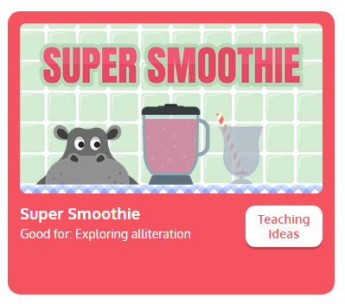 | Physical Development  Get creative outside with the chalk or use tape (indoor or outdoor) to create lines for the children to walk along. Can they keep to the line? If so, try hopping, skipping or jumping.  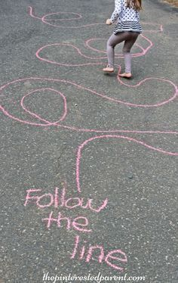  Continue to practise the development of fine motor skills. Threading, cutting, tearing, squeezing, joining with construction, playing with playdough.  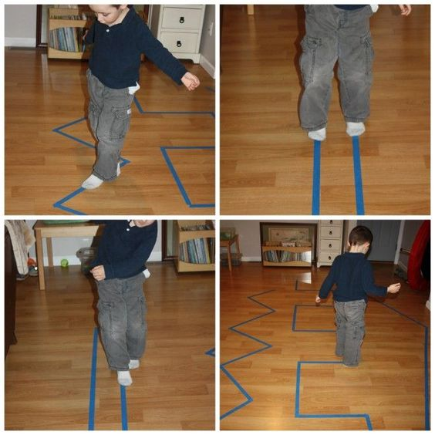  Dry spaghetti and a collinder or sieve is a great way to keep those fingers busy and practise threading. Could you make a den or habitat for one of your small toys?  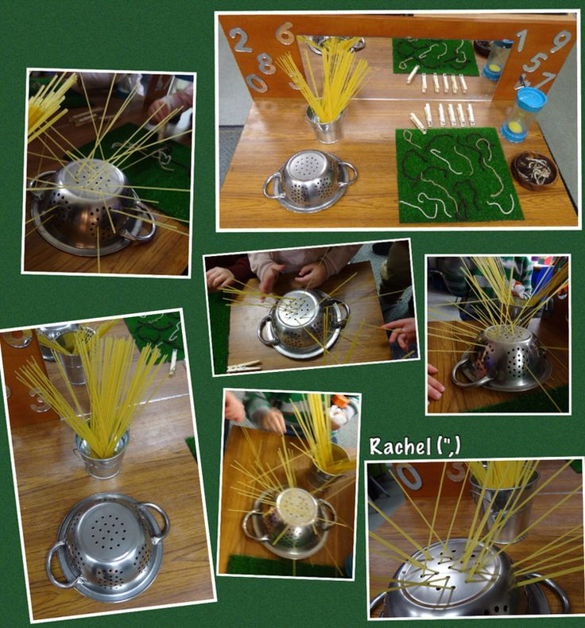  It would be great for the children going into Reception to practise writing their first name.  Please stick to lower case letters apart from their initials. Letter formation sheets are available to download on Twinkl.  www.twinkl.co.uk  Take a look at the formation for the letters in your child’s name and make a simple name card. Start with tracing over or using a yellow pen for the children to over write  Encourage your child to start at the red dot and follow the formation correctly.  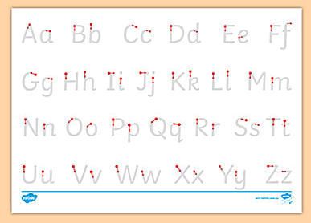
Maths  Continue to count, count and count so more!  Continue to sing a range of numbers rhymes use fingers to support language of one less.    Ask ...how many now? Count?  If you have a tablet or computer have a go at this under water counting game.  https://www.topmarks.co.uk/learning-to-count/underwater-counting  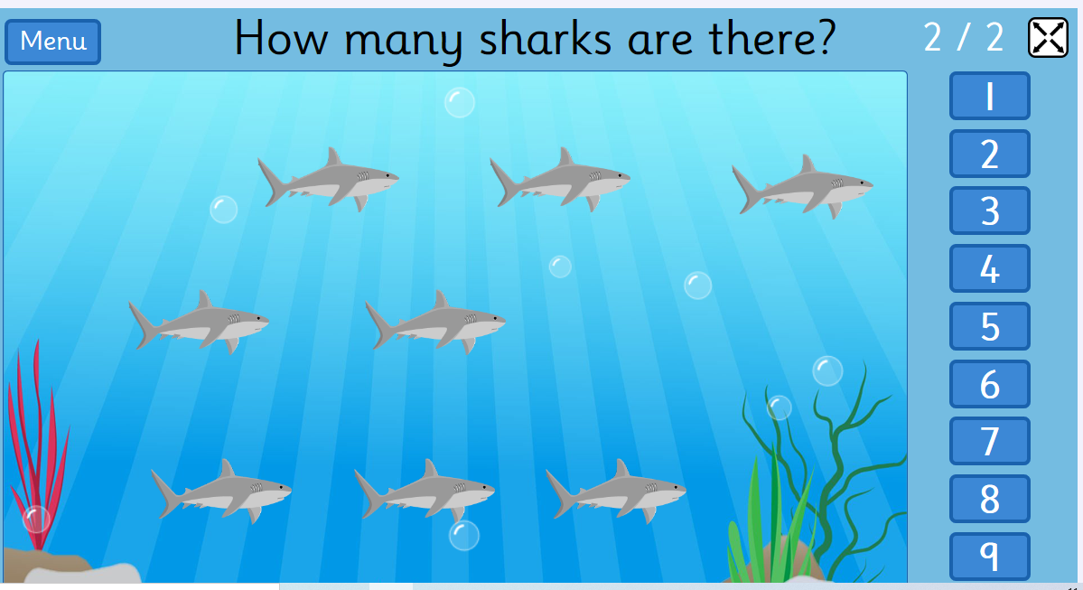 | Creative  Have a go at these craft ideas:  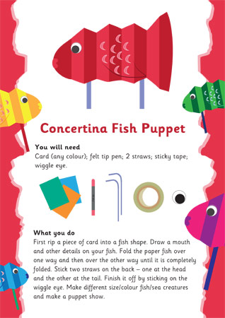  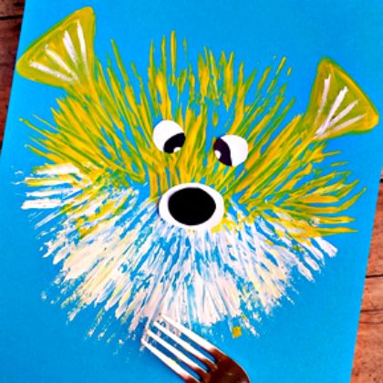  Continue to have a go at these seaside songs:  Under the sea  https://www.youtube.com/watch?v=F2gUQP-1C7A  I do like to be beside the seaside.  https://www.youtube.com/watch?v=kcHyyuGjuk0 | Knowledge and Understanding of the World  The children absolutely love this science investigation when we do it at nursery. If you have sea creatures (or any small animals) at home, give this a go. You could also give them a little hammer/ spoon/ rolling pin to see if they can chip away at the ice to free the animal.  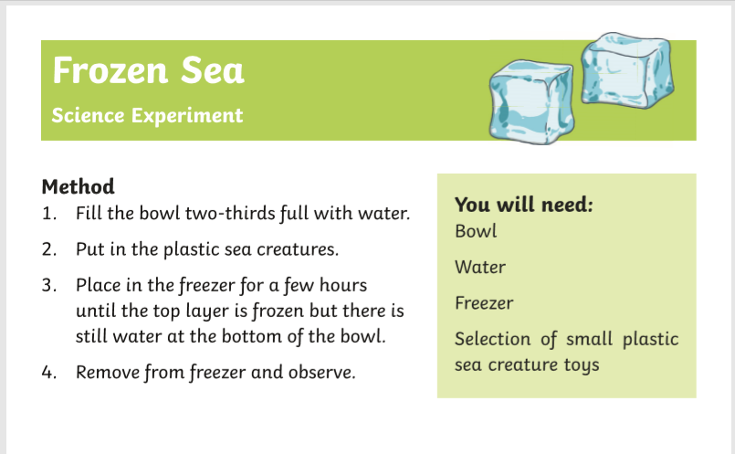  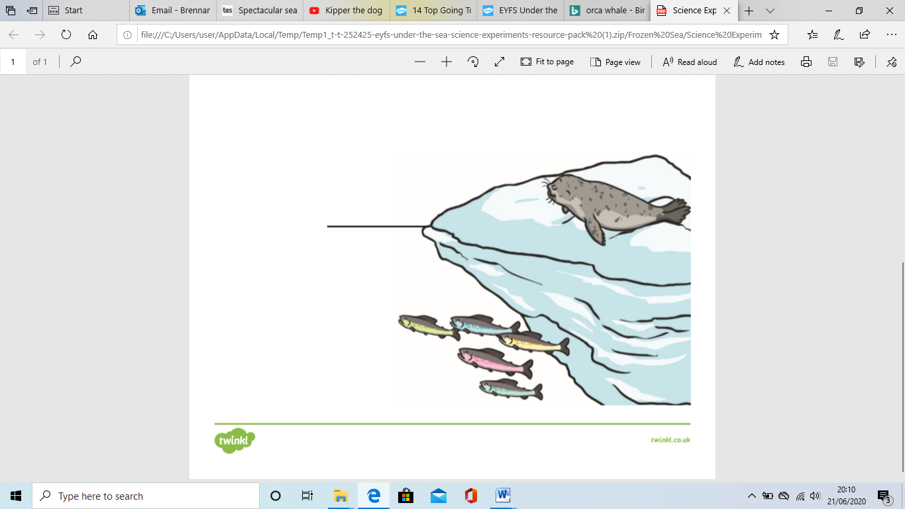  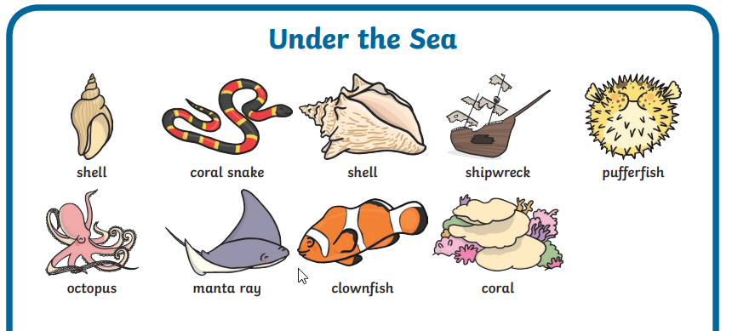  Continue to learn our new topic words:  

