Work and Resources for Home Learning in the Event of School Closure

Class: Year 6 Miss Todd
Online Resources | BBC Bitesize: https://www.bbc.co.uk/bitesize/subjects/z826n39  Topmarks (Maths and English): https://www.topmarks.co.uk/  Twinkl free resources packs: https://www.twinkl.co.uk/resource/year-3-school-closure-home-learning-resource-pack-t-e-2549912
Websites for which school has a subscription for and your child has a login | Mathletics: https://login.mathletics.com/  TT Rockstars: https://ttrockstars.com/  Bug Club: https://www.activelearnprimary.co.uk/login?c=0
Current Topic Key Questions | Current Topic: Our Local Area  Research the following:  What is the land being used for in your local area?  What has changed and what will happen?  https://www.historic-uk.com/HistoryMagazine/DestinationsUK/NewcastleuponTyne/  https://www.chroniclelive.co.uk/news/north-east-news/newcastle-schools-newbiggin-hall-simonside-17428641
Reading | Please ensure your child reads for at least 30 mins every day.
Spelling | Please check your child’s learning of the attached spellings.

league
plague
rogue
vague
fatigue
unique
antique
mosque
cheque
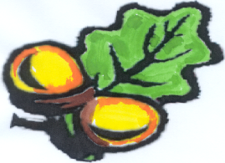
technique
Simonside
Primary School

