Work and Resources for Home Learning in the Event of School Closure

Class: Year 3/4 Miss Balmer
Online Resources | BBC Bitesize: https://www.bbc.co.uk/bitesize/subjects/z826n39  Topmarks (Maths and English): https://www.topmarks.co.uk/  Twinkl free resources packs: https://www.twinkl.co.uk/resource/year-3-school-closure-home-learning-resource-pack-t-e-2549912  https://www.twinkl.co.uk/resource/year-4-school-closure-home-learning-resource-pack-t-e-2549913
Websites for which school has a subscription for and your child has a login | Mathletics: https://login.mathletics.com/  TT Rockstars: https://ttrockstars.com/  Bug Club: https://www.activelearnprimary.co.uk/login?c=0  Purple Mash: https://www.purplemash.com/login/
Current Topic Key Questions | Current Topic: France  Research the following:  George Seuret- pointillism artist: facts about him and the art of pointillism.  Human geographical features of France  Physical geographical features of France  Comparing Newcastle to a place in France  Facts about France and the French culture  https://www.kids-world-travel-guide.com/france-facts.html  https://www.ducksters.com/geography/country/france.php  https://www.nationalgallery.org.uk/artists/georges-seurat
Reading | Please ensure your child reads for at least 30 mins every day.
Spelling | Please check your child’s learning of the attached spellings and common exception words.
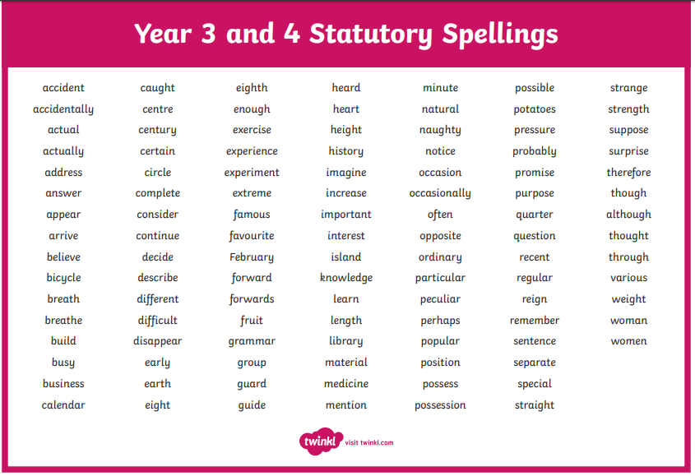
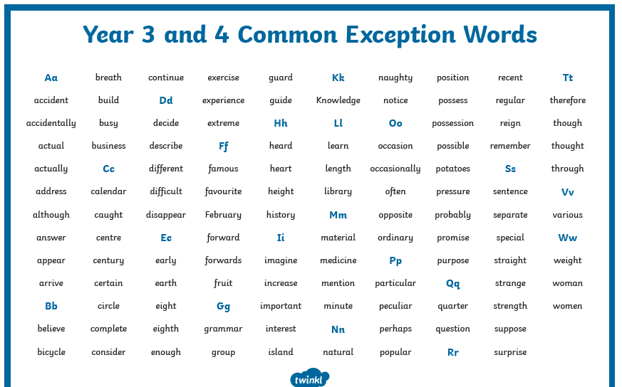
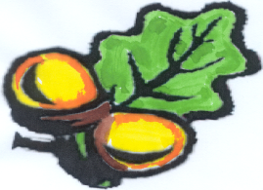
Simonside
Primary School

