Year 1/2 Weekly Homework: Week Beginning Monday 30th March 2020
Topic: Castles, Dragons, Princesses and Knights
Your home learning is your choice! There are 9 challenges to choose from below. Please try and complete 6 challenges this week.
Our intention is to upload a new home learning challenge grid each week.
Challenge 1: Literacy  Every day in class we display the date on the classroom wall.  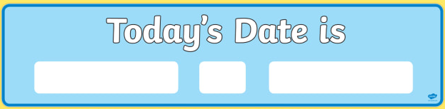  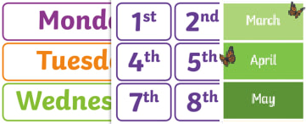  Create a diary. Write the date each day and write a simple sentence to say what you have done.  In the future your children or grandchildren might read your diary to find out about what your life was like in Newcastle in 2020. | Challenge 2: PSHE  Find a container such as a jar, a box or a special bag that you can store special things inside.  Every time that you wish you could go somewhere, treat yourself, see someone you love, visit a new place, invite people to visit you, write it on a small piece of paper and put in the container.  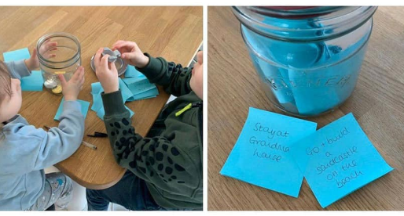  When things return to normal, this can be your bucket list of things to do. You’ll be more grateful than ever for the little and lovely things in your life! | Challenge 1: Maths  Put objects (e.g pens, pencils, socks, shoes, counters, lego bricks, sweets) into groups of 2, 5 or 10 and count in 2s, 5s and/or 10s to find the total. Now find as many 2p, 5p or 10p coins as you can in your house. Count in 2s, 5s or 10s to find the total.  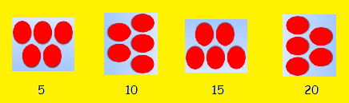  Challenge for Year 1 Pupils: Can you write addition number sentences to match to show the total amount?  Challenge for Year 2 Pupils: Can you write addition number sentences and multiplication number sentences to match to show the total amount?  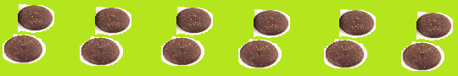  2 + 2 + 2 + 2 + 2 + 2 =  6 x 2 =
Challenge 4: Geography  Use a map/Google Maps to find out where you live and where Queen Elizabeth II lives most of the time. Do you live near the queen or far away? How long would it take you to walk to the Queen’s home? How long would it take to go in a car?  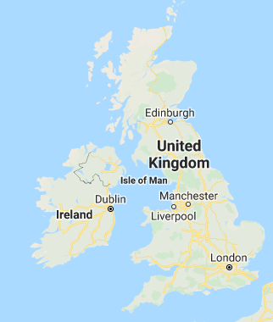 | Challenge 5: Phonics/Reading  Use www.Lexiacore5.com to read for at least 15 minutes each day.    Reading is the key to success in all curriculum areas. | Challenge 6: History  Use this webpage to find out when our queen, Queen Elizabeth II, first sent an email.  https://www.natgeokids.com/uk/discover/history/ monarchy/facts-about-the-queen-elizabeth-ii/    Make a timeline (out of strips of paper) that shows when she first sent an email, now (2020), when you were born, when your parent/s or carer/s were born and when you grandparents were born. Can you use words to describe how long ago Queen Elizabeth II sent her first email?
Challenge 7: Design Technology  Design and make your own crown that could be used at the coronation of the next king or queen.  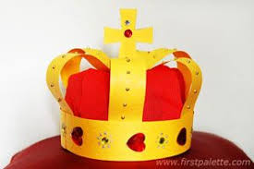 | Challenge 8: Physical Education  Please try to keep active for at least 60 minutes each day.  Design and make an obstacle course in your house or in the garden. Get your grown up to check that it is safe for you to use.  How fast can you complete it? | Challenge 9: Science  Collect items from around your home that are made from different materials e.g. wood, plastic, textiles, metal, paper. Sort them into colours and use them to create a rainbow.  

