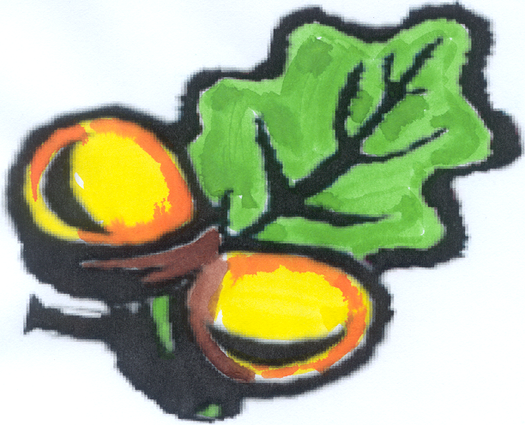
Simonside
Primary School


Simonside Community Primary School
Bedeburn Road
Newcastle-upon-Tyne
NE5 4LG
Telephone (0191) 2860776 Fax (0191) 2716790
Dream, Believe and Achieve!

Website www.simonside.newcastle.sch.uk

Email admin@simonside.newcastle.sch.uk
Date: 17.07.20

Dear Parents and Carers

Today we officially break up for the summer but do so with very mixed feelings. We haven’t been able to do all the normal lovely things such as summer fairs, summer picnics, graduations, leavers assemblies, residential, sports days and meeting our new teachers. The year has certainly not finished as we planned and we are sorry for the things they have missed, but also so grateful that we have all stayed safe and strong throughout this pandemic.

I am so proud of our children and how they have coped during this lockdown but equally proud of you as families as you have taken on the roles of teacher and done so without notice or preparation.

Thank you also to our wonderful Simonside staff team who have been working so hard throughout this lockdown whilst also managing their own family situations. A special thank you to our caretaker, cook and cleaners who have been in school every day. Myself and Mrs Hills have certainly taken on different roles delivering packed lunches, work packs and many other various things. I will look back on these times and remember the positive conversations shared with you while we have been out and about in the community.

We will be so happy to see everyone return in September and while it will be a bit different we will continue to work together to support your children. Please make sure you have read the September 2020 information to ensure we can have a smooth start back. If anything changes over the summer, we will of course update you.

We send a fond farewell to Ms Johnson who is going back to university in September. She will be really missed by all the staff and children but we are happy that she is following her dreams!

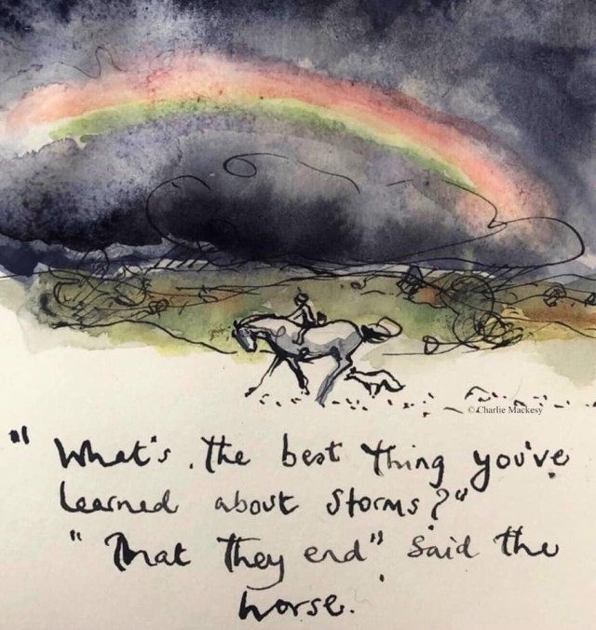
Finally, the poem, ‘The Rainbow Children’, really highlights what I believe our children have been through during this lockdown but also what they can achieve.

Take care and stay safe!

Best wishes
L Thompson
Mrs Thompson
Head Teacher



